Structural Technical Advisory Committee – Errata/Annual Amendment
8th Edition (2023) Florida Building Code, Building

S - FBC-B - Ch. 2 – Proposed Annual Amendment

Date: October 27, 2023

To: James Schock, P.E, Chairman, Florida Building Commission

From: Joe Belcher,FHBA Code Consultant

IN RE: Change to Wind-Borne Debris Definition Florida Building Code 8th Edition (2023)

While we are not sure the requested change by FHBA strictly meets the criteria for a Glitch Change,FHBA believes the Florida Building Commission has the authority to make this change due to the unintended consequences and the deleterious effect on the home buying public. FHBA strongly believes the change generates severe unintended consequences by significantly expanding the wind-borne debris region in Florida with no justification or discussion of the far reaching impact or cost. There was no discussion at the Structural TAC or Commission meetings regardingf this change's extensive and costly impact.
The graphic below depicts the magnitude of the change on a single lake with 5,000 feet of fetch.

The state of Florida has many such lakes. The FEMA MAT Reports for Hurricanes Katrina, Charley, Irma and Michael were reviewed, and there is no reporting of wind-borne debris damage due to the failure of glazed openings caused by wind-borne debris a mile from the shoreline of an inland lake of any size.

The Florida modification (Mod S9473) and the I-Code change (G12-19) indicate the change is a clarification to eliminate confusion.The cost impact statements for both say it will not increase or decrease the construction cost. (See Code Change G12-19 Part II at the end of this document.)

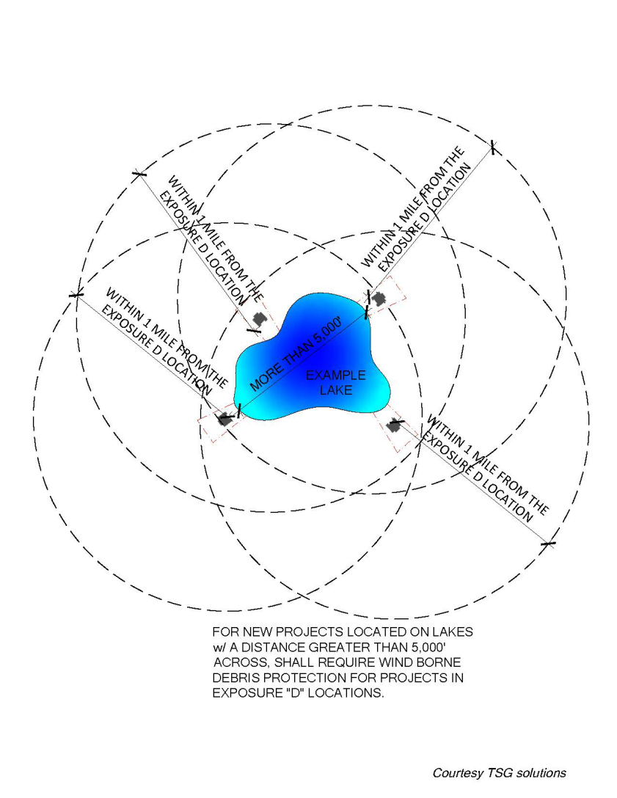

A builder in Lake County provided a cost estimate to upgrade to impact-resistant windows and sliding glass doors in a house he is currently designing. The upgrades almost doubled the window and door costs from $12,361 to $24,874, an increase of $12,513.00,.The NAHB reports a $1,000 increase in the price of of a new home will further price 140,436 U.S. household s out of the market. The builder's estimate is not an isolated instance in Lake County. Following is a list of lakes in the Central Florida region, including their fetch in feet, that will be affected by this change:

Lake County
- Lake Apopka, one side is Lake County; the other is Orange County, 39,311 feet
- John's Lake, 8,530 feet
- Clermont Chain of Lakes (largest listed below)
- Lake Louisa 14,488 feet
- Lake Minnehaha 17,057 feet
- Lake Minneola 11,482 feet
- Lake Harris Chain of Lakes (largest listed below)
- Big Lake Harris 27,814 feet
- Little Lake Harris 28,497 feet
- Lake Eustis 25,387 feet
- Lake Dora 28,592 feet
Lake Griffin 2,316 feet
- St. Johns River (Astor area)

- Sumter County
- Lake Panasoffkee 42,637 feet

- Marion County
- Lake Weir 18,648 feet

- Volusia
- Lake George 62,247 feet

- Polk County
- Arbuckle
- Lake Alfred 7309 feet
- Lake Ariana 56,492 feet

- Seminole County
- Lake Monroe (and Volusia County)
- Lake Jesup/Lake Harney 14,658 feet

- Orange County
- Lake Conway 5944 feet
- Butler Chain of Lakes
- Lake Butler 7,769 feet
- Lake Down7893 feet
- Lake Tibet 10,790 feet
- Lake Louisa 14,488 feet

- Osceola County
- Lake Kissimmee 61,062 feet
- Lake Tohopekaliga 43,270 feet

“NAHB recently released its 2023 priced out estimates, showing how higher prices and interest rates affect housing affordability. The new estimates show that 96.5 million households are already not able to afford a median priced new home in 2023 due to the fact that their incomes are insufficient to qualify for the required mortgage under standard underwriting criteria. If the median new home price goes up by $1,000, an additional 140,436 households would be priced out of the market. These 140,436 households would qualify for the mortgage before the price increase, but not afterward.”(Source: https://eyeonhousing.org/2023/03/nahb-2023-priced-out-estimates-state-and-local-estimates/
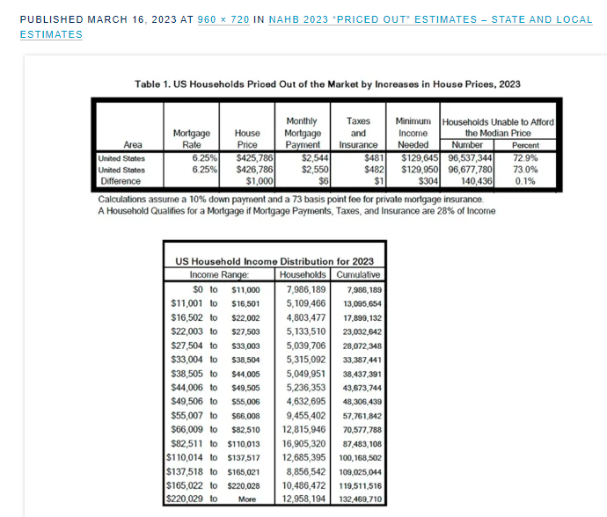
“The underwriting criterion used to determine affordability is that the sum of mortgage payments, property taxes, homeowners and private mortgage insurance premiums (PITI) during the first year is no more than 28 percent of the household’s income. Key assumptions include a 10% down payment, a 30-year fixed rate mortgage at an interest rate of 3.5%, and an annual premium starting at 73 basis points for private mortgage insurance”.Recent reports indicate that mortgage rates are increasing and will soon be at 8 percent.
As usual, NAHB’s latest update includes priced out estimates for all states and metropolitan areas. The priced out numbers vary with both the sizes of the local population and the affordability of its new homes. Among all the states, Florida registered the largest number of households priced out of the market by a $1,000 increase in the median-priced home in the state (9,573), followed by Texas (9,151), and California (7,243), largely because these three states are the top three populous states”.Source: https://eyeonhousing.org/2023/03/nahb-2023-priced-out-estimates-state-and-local-estimates/slide1-243/s://eyeonhousing.org/2023/03/nahb-2023-priced-out-estimates-state-and-local-estimates/slide1-243/
FHBA is aware that the code provides alternatives to impact-resistant glazing for opening protection that may be cheaper than impact-resistant windows. However, the alternates present other insurmountable issues, such as storing wood structural panels or removable manufactured panels and installation hardware. The hassle of installing the removable panels and removing them after the storm could delay citizens starting the installation, which could result in injuries to citizens installing them in inclement weather or on elevated openings. Such systems are also not suitable for elderly citizens.

Accordingly, the FHBA requests the following changes in the FBC-R and the FBC-B 8th Edition (2023):

Delete as follows
From FBC-B-Section 202
WINDBORNE DEBRIS REGION. Areas within hurricane-prone regions located in accordance with one of the following:

Within 1 mile (1.61 km) of the coastal mean high-water line where an Exposure D condition exists upwind at the ultimate design wind speed, V ult , is 130 mph (58 m/s) or greater.

In areas where the ultimate design wind speed, V ult , is 140 mph (63.6 m/s) or greater; or Hawaii.

Add as follows to FBC-Bsection 202
202[WIND-BORNE DEBRIS REGION. Areas within hurricane-
prone regions located:

1. Within 1 mile (1.61 km) of the coastal mean high water
line where the ultimate design wind speed, Vult, is 130
mph (58 m/s) or greater; or
2. In areas where the ultimate design wind speed, Vult, is
140 mph (63.6 m/s) or greater.
For Risk Category II buildings and other structures and
Risk Category III buildings and other structures, except
health care facilities, the wind-borne debris region shall be
based on Figure 1609.3(1). For Risk Category III health care
facilities, the wind-borne debris region shall be based on Figure
1609.3(2). For Risk Category IV buildings and other
structures, the wind-borne debris region shall be based on
Figure 1609.3(3).

Delete as follows from the FBC-Rsection R202

Delete as follows
From FBC-B-Section 202
WINDBORNE DEBRIS REGION. Areas within hurricane-prone regions located in accordance with one of the following:

Within 1 mile (1.61 km) of the coastal mean high-water line where an Exposure D condition exists upwind at the ultimate design wind speed, V ult , is 130 mph (58 m/s) or greater.

In areas where the ultimate design wind speed, V ult , is 140 mph (63.6 m/s) or greater; or Hawaii.
Add as follows FBC-R

R202WINDBORNE DEBRIS REGION. Areas within hurricane-
prone regions located in accordance with one of the
following:
1. Within 1 mile (1.61 km) of the coastal mean high water
line where the ultimate design wind speed, Vult, is 130
mph (58 m/s) or greater.
2. In areas where the ultimate design wind speed, Vult, is
140 mph (63.6 m/s) or greater; or Hawaii.

Fiscal Impact Statement [Provide documentation of the costs and benefits of the proposed modifications to the code for each of the following entities. Cost data should be accompanied by a list of assumptions and supporting documentation. Explain expected benefits.]:

A. Impact to local entity relative to enforcement of code: No impact the current definition will be retained.

B. Impact to building and property owners relative to cost of compliance with code: The change will decrease the cost for property owners as the cost of providing impact resistant windows and glass doors is at least double the cost standard windows and glass doors.

C. Impact to industry relative to cost of compliance with code:The change will reduce the constructioncost to the industry, which will be passed on to the homebuyer and will therefore avoid decreasing those in the market able to purchase a home.

Rationale [Provide an explanation of why you would like this Proposed Modification to the Florida Building Code.]: There is a Florida specific need for the requested changes due to the great number of large inland lakes in the state. The change will avoid adopting a costly provision for which there is no justification and no proven need. The changes will eliminate the decrease in the ability of a large number of members of the public to qualify for a home mortgage.

Please explain how the proposed modification meets the following requirements:
1. Has a reasonable and substantial connection with the health, safety, and welfare of the general public:The changes have a reasonable and substantial connection with the health safety and welfare of the general public by decreasing the cost of construction and eliminating a provision for which there is no justification and no proven need.

2. Strengthens or improves the code, and provides equivalent or better products, methods, or systems of construction:The changes Improve the code by decreasing the cost of construction and eliminating a provision for which there is no justification and no proven need, which will decrease the number of members of the public able to qualify for the purchase of a home.

3. Does not discriminate against materials, products, methods, or systems of construction of demonstrated capabilities:The change does not discriminate against materials products method sources of the construction of demonstrated capabilities

4. Does not degrade the effectiveness of the code: The changes do not degrade the effectiveness of the code.

Code Change No:G12-19 Part II

Original Proposal

Section(s): IRC: [RB]202

Proponent: Don Scott, Representing National Council of Structural Engineers Association, representing National Council of Structural Engineers Association (dscott@pcs-structural.com)

THIS IS A TWO PART PROPOSAL. PART I WILL BE HEARD BY THE IBC-STRUCTURAL COMMITTEE. PART II WILL BE HEARD BY THE IRC-BUILDING COMMITTEE. PLEASE CHECK THE RESPECTIVE HEARING AGENDAS.

2018 International Residential Code
[RB] WINDBORNE DEBRIS REGION. Areas within hurricane-prone regions located in accordance with one of the following:

Within 1 mile (1.61 km) of the coastal mean high-water line where an Exposure D condition exists upwind at the waterline and the ultimate design wind speed, V ult , is 130 mph (58 m/s) or greater.

In areas where the ultimate design wind speed, V ult , is 140 mph (63.6 m/s) or greater; or Hawaii.

Reason: Significant confusion has arisen in hurricane-prone regions in trying to determine wind-borne debris regions because the term "coastal mean high waterline" in not a mapped or defined term. Due to this lack of definition, some jurisdictions have incorrectly interpreted areas within one mile of the mean high waterline along narrow inland tidal waterways to be in wind-borne debris regions. The primary intent behind paragraph No. 1, is that within one mile of the coast, hurricane wind speeds will be governed by the wind speed over the open water, i.e. an Exposure Category D rather than an inland Exposure Category C situation on which the basic wind speed and paragraph No. 2 are based. This CCP clarifies that the waterline has to be classified as an Exposure D in order for paragraph No. 1 to apply. It also deletes the word "coastal" since wind speed increases could occur at large inland waterways in hurricane-prone regions as well. Also, NOAA maintains a database of the "mean high waterline" values in the US, which can be used in conjunction with this definition.

Cost Impact: The code change proposal will not increase or decrease the cost of construction
This code change proposal is location dependent on its impact on construction costs, however by providing a definition of the wind-borne debris zone, it will eliminate confusion as to where to apply the wind-borne debris protection requirements.

TAC Recommendation: Retain 7th Edition Definition Pending a Study.

Commission Action:

Comment 1 –

BOAF Building Officials Association of Florida CDC Code Development Committee

Proposal: Correcting reference figures as noted below
Delete as follows
From FBC-B-Section 202
WINDBORNE DEBRIS REGION. Areas within hurricane-prone regions located in accordance with one of the following:

Within 1 mile (1.61 km) of the coastal mean high-water line where an Exposure D condition exists upwind at the ultimate design wind speed, V ult , is 130 mph (58 m/s) or greater.

In areas where the ultimate design wind speed, V ult , is 140 mph (63.6 m/s) or greater; or Hawaii.
Add as follows FBC-R
R202WINDBORNE DEBRIS REGION. Areas within hurricane-
prone regions located in accordance with one of the
following:
1. Within 1 mile (1.61 km) of the coastal mean high water
line where the ultimate design wind speed, Vult, is 130
mph (58 m/s) or greater.
2. In areas where the ultimate design wind speed, Vult, is
140 mph (63.6 m/s) or greater; or Hawaii.
Comment: Consider adding note
3. Inland lakes and waterways: Property adjacent to large bodies of water
where an Exposure D condition exists and the ultimate design wind speed, Vult, is 130
mph (58 m/s) or greater.

This revision would also require that note 7 be stricken from Figure R301.2 (4)
Approve/Oppose: Approve and support as being a glitch

Comment 2 –

From: Don Scott <Don@DonScottConsulting.com>
Sent: Tuesday, November 28, 2023 5:35 PM
To: Madani, Mo <Mo.Madani@myfloridalicense.com>
Cc: Goupil, Jennifer <jgoupil@asce.org>
Subject: Windborne Debris Definition

[NOTICE] This message comes from a system outside of DBPR. Please exercise caution when clicking on links and/or providing sensitive information. If you have concerns, please contact your Knowledge Champion or the DBPR Helpdesk.

Mo,

It is has been a long time since we have talked, so I hope things are going well for you.

I reviewed the proposal by NAHB and Joe Belcher from FHBA to change the Wind-Borne Debris definition in the Florida Building Code.

Mr. Belcher and NAHB are proposing to revise the definition to limit the wind-borne debris regions to along the Atlantic and Gulf coasts and eliminate its application to the larger lakes and waterways. This change is against the intent of the definition of the wind-borne debris region contained in ASCE 7, that has been adopted into the Florida Building Code. The definition in ASCE 7 reads as follows:

"26.12.3.1 Wind-Borne Debris Regions Glazed openings shall be protected in accordance with Section 26.12.3.2 in the following locations:
- Within 1 mil (1.6 km) of the mean high water line where and Exposure D condition exists upwind of the waterline and the basic wind speed in equal to or greater than 130 mi/h (589 m/s), or
- In areas where the basic wind speed is equatl to or greater than 140 mi/h (63 m/s)."
As you can see there is no limitation to these provisions being limited to only ocean coastlines and they are applicable to large lakes and waterways.

Thus, I would recommend rejection of the change being proposed.

Let me know if you have any questions.

Thanks for your consideration.
Don Scott

Comment 3 – See attachment #1 ( Members of the FHBA – 157 comments in support of Glitch #1)

Comment 4 –

From: Belcher, Joe <Joe@jdbcodeservices.com>
Sent: Monday, February 12, 2024 8:21 PM
To: Madani, Mo <Mo.Madani@myfloridalicense.com>; Michael Bourré <mbourre@bourreconstructiongroup.com>; John Carlson <jcarlson@whartonsmith.com>; Rusty Payton <rpayton@fhba.com>; Frank Severino <Frank@bsahe.com>; Mike Keesee <mike.keesee@mytsghome.com>; Carl Brown <carl.brown@mytsghome.com>; Scott McCracken <sawhorseconst@bellsouth.net>; Rob Willets <robert.willets@ashtonwoods.com>; William Webb <webbhbg@gmail.com>; Jeremy Stewart <jeremystewart@crestviewhomes.com>; Ray Puzzitiello <ray@puzzitiello.com>; Alton Lister <Lbldr@aol.com>; TJ Thornberry <tj@thornberrycustombuilders.com>; Alan Gremillion <alan.gremillion@glhomes.com>; Niki Norton <niki@n2archdesign.com>; Tatiana Gust <tgust@elitepermits.com>
Subject: Public Comment on the Change to Wind-Borne Debris Definition Florida Building Code 8th Edition (2023)

[NOTICE] This message comes from a system outside of DBPR. Please exercise caution when clicking on links and/or providing sensitive information. If you have concerns, please contact your Knowledge Champion or the DBPR Helpdesk.

Mo,
Please consider the following as a public comment from FHBA on the discussion by the Florida Building Commission at the February 13, 2024, meeting related to the definition of the Windborne Debris Region.
Thank you,

Joe Belcher

Joseph D. Belcher, Code Consultant
JDB Code Services Inc.
41 Oak Village Boulevard
Homosassa, Florida 34446-5632
Joe@jdbcodeservices.com
(352) 450-2631 Vox
(352)-302-0825 Cell
(352) 503-0155 Skype
(813) 925-4152 Fax

I want to start my comment by apologizing to the Florida Building Commission, the Structural TAC and the attendees at this meeting. I accept a share of the responsibility for the potentially tragic impact this change could have on affordable housing in Central Florida and the Panhandle. I discussed this change with the Florida proponent, and neither of us had an inkling of the ramifications on affordable housing in Central Florida and the Panhandle. Upon looking at the lakes in Central Florida, we realized we had no idea there were so many large lakes in the central part of the state. FHBA believes the Florida Building Commission has the authority to and should consider adopting this change via the annual technical amendment process.
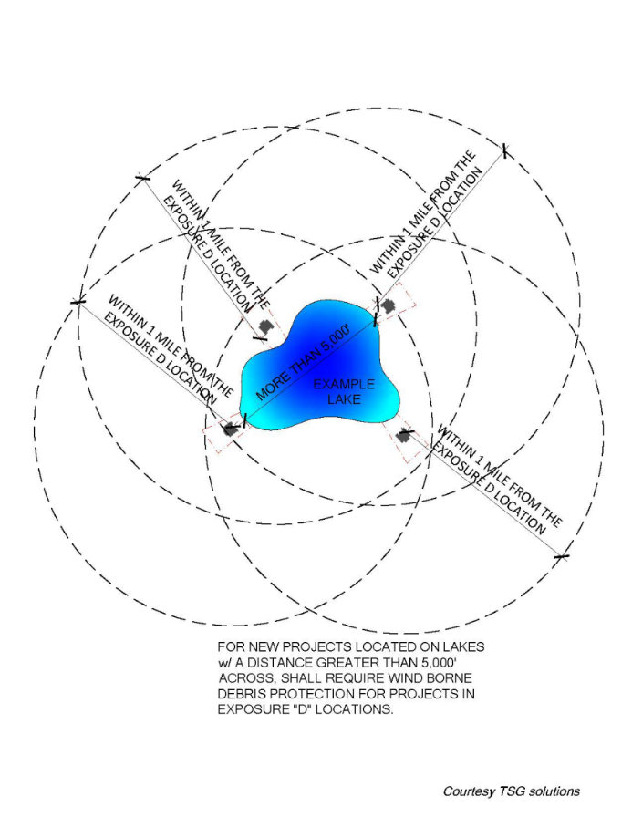
The change is justified due to the unintended cost consequences and the significant negative impact on the Florida home-buying public. FHBA strongly believes the change generates severe unintended consequences by significantly expanding the wind-borne debris region in Central Florida and the Panhandle without a proven need or proper discussion of the far-reaching impact and cost. There was no discussion by the Structural TAC or the Commission regarding the change's extensive and costly impact. Below is a graphic prepared by a Florida Professional Engineer member of the FHBA Codes and Standards Committee depicting the magnitude of the change on a single lake with 5,000 feet of fetch.

We respectfully request The Florida Building Commission initiate rulemaking to retain the definition of the Wind–Borne Debris Region of the Florida Building Code 7^{tth}Edition (2023) as an annual technical amendment for the following reasons:
- There is no science behind the definition of wind-borne debris region.
  - When we debated whether to include wind-borne debris regions in the first edition of the FBC (2001), Dr. Peter Vickery of ARA testified before the Commission that there was no science behind the definition of wind-borne debris region. The definition was an educated guess and a compromise between competing interests.
- There is no demonstrated problem or need for the change.
- There was no discussion of the cost impact by the Structural TAC
- There was no discussion of the cost impact by the Florida Building Commission.
- Expense - A Lake County builder's cost for windows and doors on a house uder design almost doubled. ($12,361 to $24,874.)
- Another builder in Belair Park in Sanford stated their starter home would increase by $1,400 using cloth hurricane panels and $4,200 or more for impact-resistant glazing, depending on the brand of the window or door used.
- The change to ASCE7-22 has a much more significant impact in Florida than in other states because Florida is a much larger hurricane-prone region with many large lakes.
- The change does not affect the entire state but significantly impacts Central Florida and parts of the Panhandle.
- The change does not affect the HVHZ because the entire region is designated a wind-borne debris region.
- Adopting the revised definition will significantly impact housing affordability in Central Florida and the Panhandle.
- FEMA Mitigation Assessment Team (MAT) post-event reports do not mention wind-borne debris damage in inland lake areas.
- MAT Reports for Hurricanes Katrina, Charley, Irma, and Michael do not cite any wind-borne debris damage around inland lake areas.
- The proponents of the change to the Florida Building Code and the International Codes stated there was no increase or decrease in construction cost due to the change.
- Adopting the revised definition will significantly impact housing affordability in Central Florida and the Panhandle.
- A $1000 increase in the median-priced home in Florida results in 9,573 families being priced out of the housing market.

- The 9,573 households would qualify before the increase but not afterward.

- It is unconscionable to render thousands of Florida citizens ineligible for a mortgage for the three years it would take to effect a change through the FBC process or the five years for the ASCE 7 process.

- Experience demonstrates that new editions of ASCE 7 often require a significant correction in the next edition. E.g.
  - ASCE7 - 22 Corrects the overly complicated and restrictive roof design provisions of ASCE7-16.
  - Steel buildings on the Florida coast designed per ASCE7 – 98 had to lean into the wind to meet design requirements,n which was corrected in ASCE7-02.
Accordingly, the FHBA respectfully requests the Florida Building Commission initiate rulemaking to retain the current definition of the Wind-borne Debris Region in the Florida Building Code - Building and Residential in the Florida Building Code 8th Edition.

Respectfully Submitted,
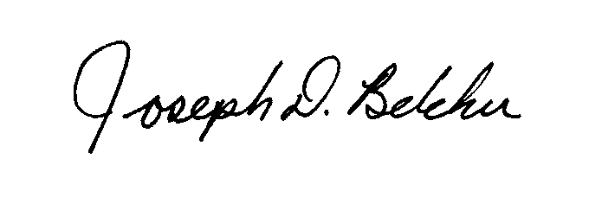
Joseph D Belcher,FHBA Code Consultant

8th Edition (2023) Florida Building Code, Residential

CHAPTER 3 BUILDING PLANNING

S - FBC-R - Ch. 3 – Errata #2 - (Received after deadline 12/5/2023)

From: gjohnsonconsulting@gmail.com <gjohnsonconsulting@gmail.com>
Sent: Tuesday, December 5, 2023 10:15 AM
To: Madani, Mo <Mo.Madani@myfloridalicense.com>
Cc: 'Cade Booth' <cbooth@awc.org>
Subject: FW: Glitch/Errata Comment Period - submit by December 30, 2023

[NOTICE] This message comes from a system outside of DBPR. Please exercise caution when clicking on links and/or providing sensitive information. If you have concerns, please contact your Knowledge Champion or the DBPR Helpdesk.

Hi Mo,

Cade Booth, AWC’s new (relatively), manager of the SE Region, including FL, caught a naming error in the FBC’s Section R301.1.1 reference to the Wood Frame Construction Manual.

It’s not a technical glitch, it’s just that the name of the publisher didn’t get updated (several cycles ago) previously.

Is this the kind of thing that staff can address administratively? There is no technical impact. It seems like it would be a waste of Commission or TAC resources to make it their deal.

What can be done?

Thanks,

Greg

Principal
Johnson & Associates Consulting Services
Analysis & Advocacy
gjohnsonconsulting@gmail.com
651.235.1215

From: Cade Booth <cbooth@awc.org>
Sent: Monday, December 4, 2023 4:16 PM
To: gjohnsonconsulting@gmail.com;
Subject: RE: Glitch/Errata Comment Period - submit by December 30, 2023

FBC R301.1.1 refers to the AF&PA Wood Frame Construction Manual… should read AWC WFCM. References does correctly list the doc as AWC and as such its use is allowed, but correction is needed.

Would it be possible to get the following corrected via this glitch process? If not, when and where is the place in Florida? Thoughts?

TAC Recommendation: Errata - AS

Commission Action:

